Providing Collaborate Recordings to Students After the Session is Over

- Go into Blackboard Collaborate Ulta and click on the icon in the top left with three white lines.
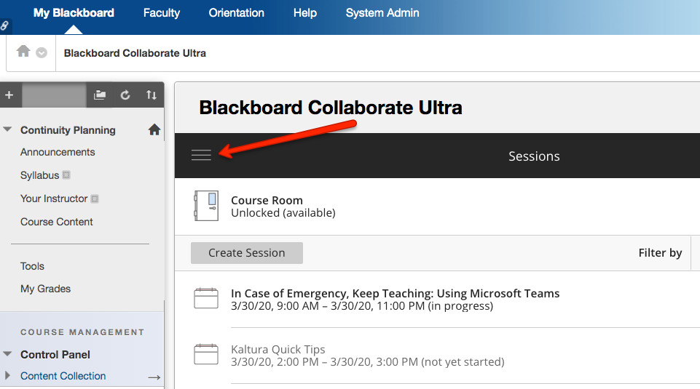
- Choose Recordings from the drop-down menu that appears.
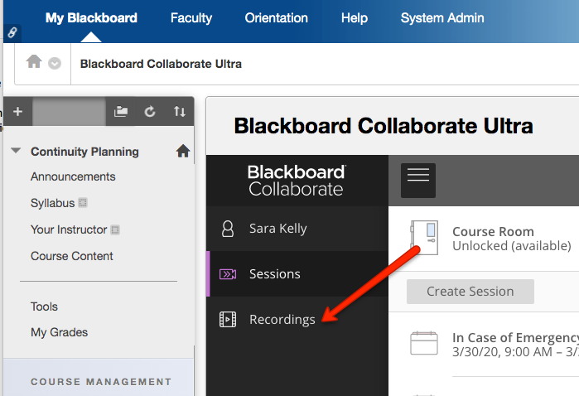
- Find the recording you want students to see and click on the icon that looks like a small circle with three dots in it. Then choose Copy Link.
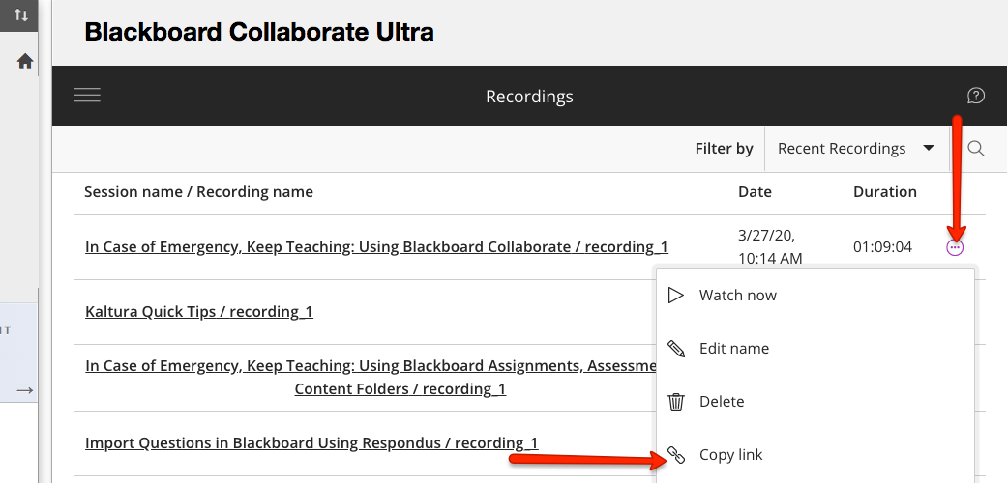
- Go to Course Content and find the place where you will direct students to watch the recordings. Click on Build Content and choose Web Link. 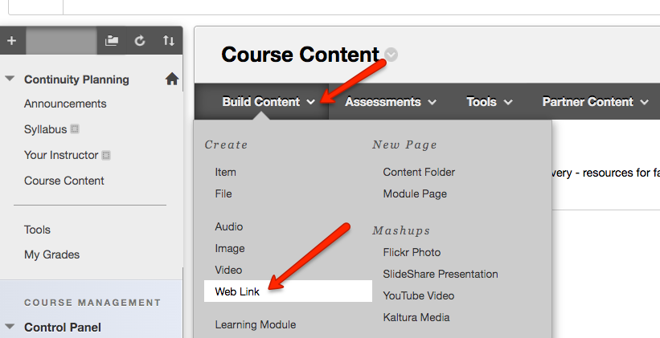
- Give the link a name and paste the link (right click and choose Paste) you copied in Step 3 into the URL text area. Then click Submit.
